**Git Bash Command**

Configuring Username and Email in git:

$ git config --global user.name sagarhasan273

$ git config --global user.name

$ git config --global user.email sagarhasan273@gmail.com

$ git config --global user.email

To Open VsCode:

$ code .

Init Command:

$ git init

$ ls -lart

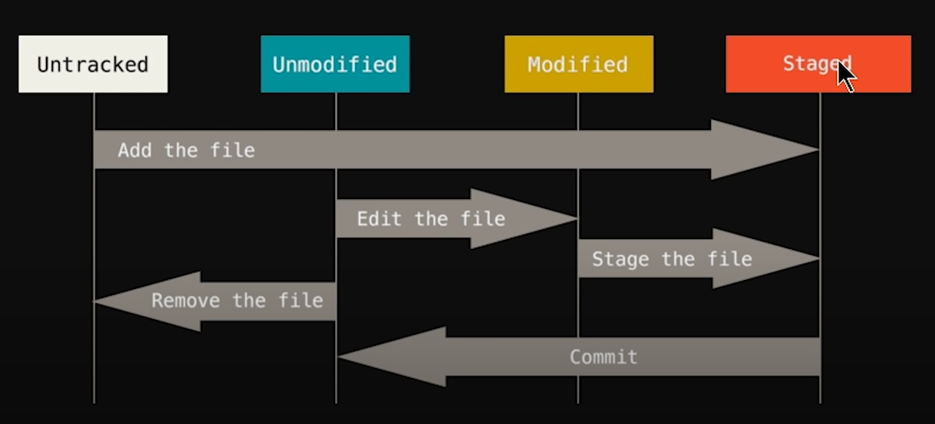

$ git status

$ git commit -m "Initial commit" [Good to use it]

$ git config --global core.editor "code --wait"

**Untracked:**

$ git add index.html

$ git add -A [To add all]

$ git commit -m “Initial commit” [Good to use it]

**If git commit create a problem-**

Press I and write “INITIAL COMMIT” + Esc + : + w + q

**Unmodified & Modified:**

$ git checkout index.html [if mistakenly gets updated]

$ git checkout -f

**Staged:**

$ git log [show all commit messeges]

$ git log -p -1

$ git diff [compare with your saved file and after editing file]

$ git diff --staged [ will only show changes to files in the "staged" area.]

$ git commit -a -m "adding waste.html"

$ git rm --cached waste.html [remove from staged area]

$ git rm waste.html [to delete]

$ git commit -a -m "deleting waste.html"

$ mkdir foldername

$ touch .gitignore

/log/mylog.log

*.log

**Create a new repository on the command line**

echo "# learning-git" >> README.md

git init

git add README.md

git commit -m "first commit"

git branch -M main

git remote add origin https://github.com/sagarhasan273/learning-git.git

git push -u origin main

### push an existing repository from the command line

git remote add origin https://github.com/sagarhasan273/learning-git.git

git branch -M main

git push -u origin main

git pull origin main

**Branch:**

$ git branch main

$ git branch

$ git checkout main

$ git merge main

$ git checkout -b mainlite

**Other:**

$ explorer filename

$ start filename

**If failed to push some refs to:**

$ git pull --rebase origin main/master